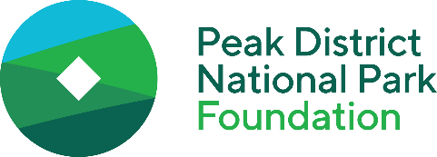
Community Nature Fund – Application Form

Please email your completed form to hello@peakdistrictfoundation.org.uk.

About you and the project site
Your name
Your email address
Your phone number
Your organisation’s name
Your organisation’s address
Which of the following best describes the status of your organisation  (please delete as appropriate) | Parish council / School / Registered charity / Charitable incorporated organisation (CIO) / Community interest company (CIC) / Community group, society or association /  Smallholder
The address of the site where the project will take place
Does your organisation own the project site? If not, please provide the owner’s name and contact details
Are there any designations on the land that you are aware of?
(e.g. site of special scientific interest, conservation area, nature reserve, listed building or scheduled monument)
Please tell us about the project site:
- what is it currently like?
- how is it currently used and who is it used by?
- who is responsible for managing and maintaining it and how do they do this?

About your project
Project title
Project summary. Please tell us about your project, including:
- your aims
- what specific activities you will carry out to achieve these aims
- who will carry out these activities
If your project involves planting trees, hedgerows, wildflowers or other plants, please tell us briefly about what specific species / types of plants you have chosen and why
When will the project take place? Please provide estimated start and end dates
How much land will the project cover?
(please use whatever units make most sense e.g. acres / hectares / square metres)
Do you need planning consent or any other licences / permissions to carry out this work? If so, have you already requested / secured these?
When you send us your completed form, please include a map / plan which shows the rough layout of the site and where the specific activities involved in your project will take place
(This does not need to be a detailed site plan or professionally-produced, a simple hand-drawn sketch is absolutely fine)

The difference your project will make
What difference will your project make for nature? Please tell us about:
- both the short and long-term outcomes (i.e. what changes you expect to happen during / shortly after the project and what further changes you expect to see over the following years)
- what species / types of wildlife you expect to benefit from your project
Will your project provide any benefits to the community and local people (e.g. by enabling more people to access and use the space or learn about nature)?

How much your project will cost
How much will your project cost in total?
How much funding are you requesting from the Community Nature Fund?
If the total cost is more than the amount you are requesting from the Community Nature Fund, how are you planning to raise the rest of the funding?
Please use the table below to provide a breakdown of the project budget. Use the ‘Notes’ column to explain how your figures have been calculated (e.g. the unit cost and quantity they are based on)

Item | Cost | Notes

If your budget includes the cost of using professionals / contractors to deliver any parts of your project, please tell us the key reasons why you cannot deliver these yourself or by using volunteers

Your plans for the future
What activities will you carry out after this project ends to continue to manage the site for nature? Your answer should cover a period of at least five years after completion of the project you are asking us to fund.

For each type of habitat / feature you are creating (e.g. pond, wildflower meadow, bird box), please tell us briefly:
- what activities will be needed to maintain it in a good condition
- who will carry out these activities
- if they have a significant cost, how you plan to raise the funds to pay for them

